Today’s Lecture Road Map
Dated: 8th June 2021
User Interface Design

- What makes a good user experience?
- What are its characteristics?
- How do you just KNOW that you're using something that has been thought out properly?

It is NOT just the UI

The experience begins with the first time you launch an app or go to a web site
There are several components here
- Initial impression (boot up to app start)
- User interface
- Graphic design
- Information presentation
- The physical device and how it is used with app

This makes the user experience (UX)
- The 10 Rules to Mobile HCI

- Visibility of Status
The system should always keep users informed about what is going on through appropriate feedback within reasonable time.
Examples:
- If your app is downloading something in the background, add an icon to the status bar
- Make sure the user knows what screen they are on
- Don’t break / hide other system status info unless necessary (i.e. time, wi-fi, etc.)

- System = Real World
The system should follow real-world conventions, making information appear in natural and logical order.
Examples:
  - When providing a list of users, what is the most logical way to order the list? By last name? By computing ID? Depends on the use case.
  - Follow common conventions for coloring (red = stop/bad/error, etc.)

- The “uh-oh” button

Users often choose system functions by mistake (particularly on mobile) and will need a clearly marked “emergency exit” to leave the unwanted state without having to go through extended steps. Systems should support undo and redo.
Examples:
- In iOS Mail, you can shake the device to undo moving a message to the trash.

- Consistency and Standards
User should not have to wonder whether different words, situations, or actions mean the same thing. The system should follow platform conventions.
Examples:
- If the iOS specs say that the + icon is only used for adding a contact, then only use it for that thing.
- Don’t usurp icons used in other platform apps to do different things.
- Leads to confusion.

- Error Prevention
When user input is hampered by a small device, add in as much assistance as possible to aid with input.
Examples:
- Add input checks
- How many digits in that phone number?
- How many digits in that credit card number?
- Are there really 39 days in July?
- Use appropriate widgets
  - Date / time spinner
  - Sliders

- Recognition rather than Recall
An icon should represent the action and should immediately recognizable as to what it does. Part of this is following platform standards, part is being consistent in your own application
Examples:
- An action/swipe/etc should be consistent across screens.
- If your “add a new thing” function is in the top right on one screen, put in there in all appropriate screens.
- Use known iconography and color schemes.

- Flexibility
Accelerators, shortcuts, etc. (which are unseen by the novice user) can speed up interactions for the expert user to such an extent that the system can cater to both inexperienced and experienced users.
Examples:
- Swipe keyboard option
- Text expanders

- Minimalist Design
Every extra unit of information in a dialog competes with the relevant units of information and diminishes their relative visibility.
Examples:
- Make sure one Activity does ONE thing and does that thing well.
- Limit the number of buttons / information areas on the screen.

- Error Explanation
Error messages should be expressed in plain language (NO CODES), precisely indicate the problem, and constructively suggest a solution.
Examples:
- “ERROR: X506923ABA happened.
- “Cannot currently connect to the service. Please check your internet connectivity and try again later.”

- Help!
Have reasonable help information available in the app if possible.
Examples:
- Shake device for pop up to offer assistance :-)

Pro Tips!
- Large, obvious buttons
- Controls toward the center of the screen so you don't have to stretch
- Controls have space between them if possible
- Put only needed items on the screen
- Eliminate unnecessary words
- Make transitions between states obvious
- Easy traversals between states
- Audio sparingly (remember – audio may be turned off!)
- Build for the input device (click wheel, touch screen, stylus)
- Provide shortcuts when possible
- Try to use direct-manipulation widgets for input with immediate feedback
- Menus must be tailored to the device input
- Typing isn't easy – provide ways to remember text
Use contextual information whenever possible (use GPS co-ords automatically in a Google search, have the last contact up for making a phone call, etc)

My app works well! … but it’s ugly… :-(
Remember: Simple is beautiful
- Simple colors
- Simple layout

Limitation is the greatest form of flattery

Check the patterns:

http://sixrevisions.com/user-interface/mobile-ui-design-patterns-inspiration/

TO DO: Select the better UI from the following and reason WHY?
- Playing Music
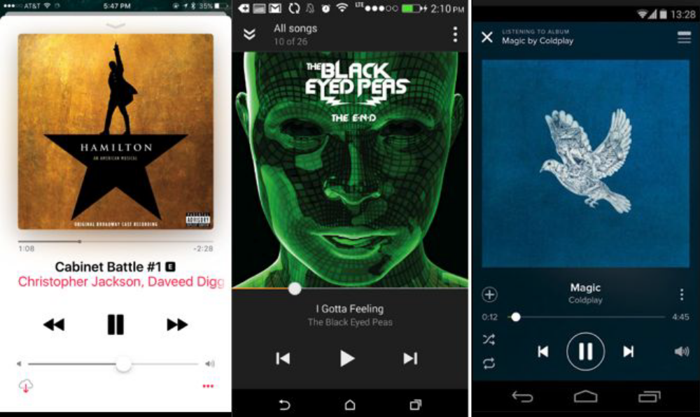
- Designing an image gallery
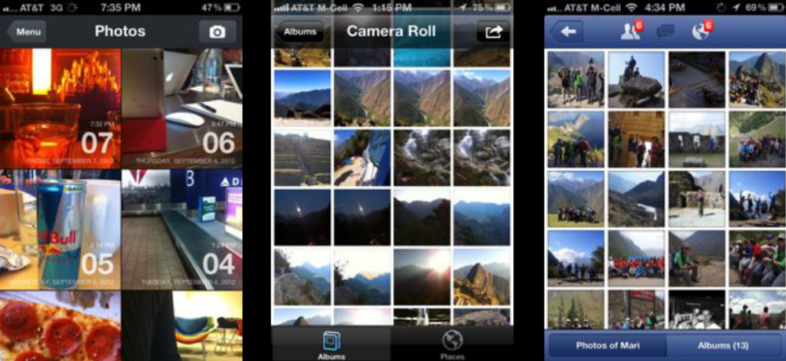

- Listing Contacts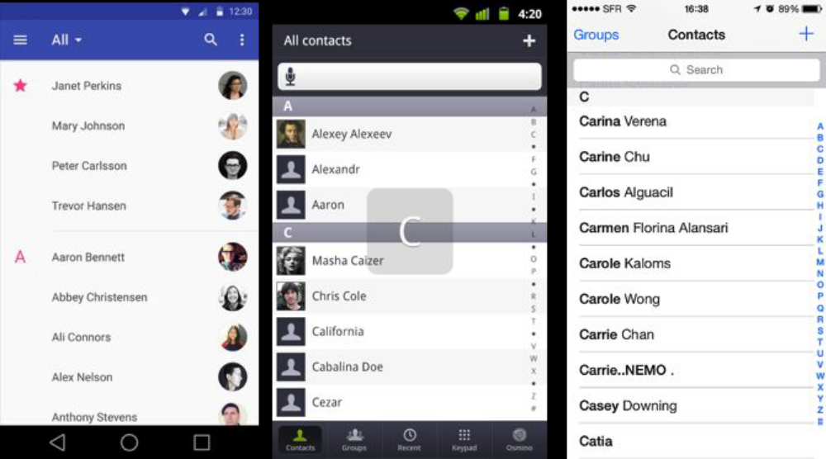
- Showing an Empty List
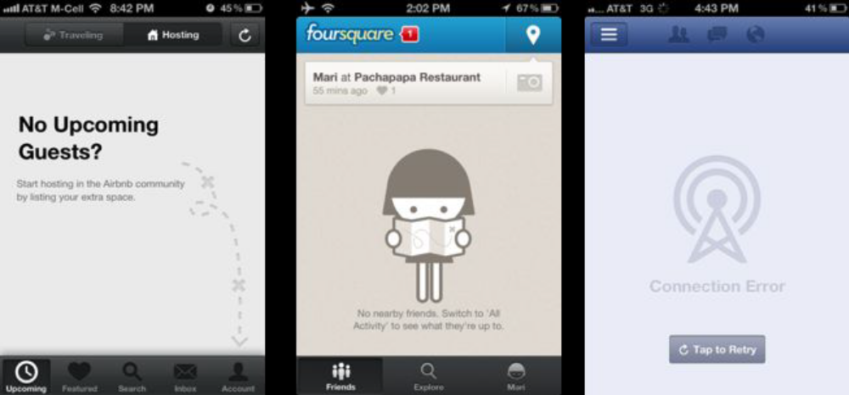

- Sending Money
